President’s Report April 2022

At each AGM for the last 10 years, I have provided our ex-students with a summary of our activities. This year is no different. All our activities are listed in dot form. The difference this time though is that this is my last report as President. I have taken the opportunity to not only look back to May 2012 and reflect on the headline: CHESS IMMEDIATE FUTURE IN JEOPARDY!!!, but list and acknowledge the tremendous work we have done as a committee over the last 10 years. There is now no doubt about our future, and I am delighted to hand on the baton to another cohort of enthusiastic ex-students. Thank you for the support and encouragement so many of you gave us. I am confident that you will continue to appreciate the work that our volunteers do to keep our society relevant and our contributions to the school impactful.

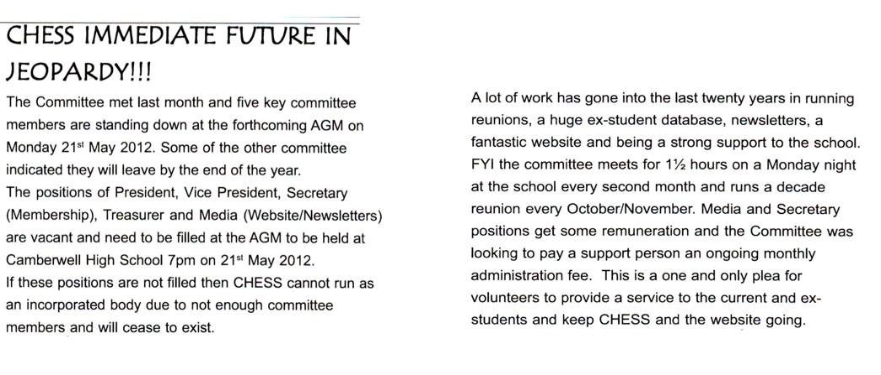
In April 2012, several of us responded to this call to keep CHESS alive. Since the formation of CHESS in the Jubilee year of 1991, a small group had worked very hard, and now it was time for others to step up and keep CHESS going. We were elected unopposed! Others joined by personal invitation.

I’m very proud of what we have accomplished in the last 10 years, particularly as some of the tasks have required large amounts of voluntary time. We have:
- Implemented correct incorporated association guidelines
- Significantly improved the database
- Got our finances in order by adopting online giving using JoinIT
- Built a new website so that it is now a substantial and accessible archive
- Organised the 1991 Hall of Fame to be professionally updated
- Created a current list of distinguished alumni and former staff on the website
- Scanned and uploaded every Prospice from 1946-2020
- Held significant events like the 70th dinner
- Had very good support for our luncheons for older members
- Held an annual end of year dinner
- Facilitated reunions and added ex-students details to the database
- Scanned and uploaded all available archives to the website (a 10-year project!)
- Increased scholarship and benevolent giving
- Increased giving to the library and developed a good relationship with the library manager
- Administered bequests
- Commenced writing a short paragraph to the school for inclusion in the bi-monthly newsletter
- Built strong relationships with the school including exiting Year 12’s
- Attended leader’s lunches, Valedictory and Presentation evenings, some musical events and openings of buildings
- Held webinars during lockdown

- Built effective communication with over 1200 ex-students via 3 newsletters a year, through Gmail and with Facebook posts
- Maintained contact with our postal cohort by monitoring our PO Box and posting newsletters
- Attended school council meetings over a number of years to raise the profile of CHESS with parents and staff
- Celebrated key milestones with the school eg 75th and 80th birthday
- Built strong relationships with former principals: Elida Brereton and Ann Rusden
- Created short videos for senior students and to promote CHESS
- Obtained Charity status for ongoing donations and bequests
- Reprinted Robert Ewins Jubilee Retrospective book in hard copy and E-print
- Developed our own merchandise including pens, bookmarks and a pull-up banner
- Accepted donations, had them scanned, uploaded to the website, then stored in the school archives or library
- Sorted the archives in the school storeroom, scanned and uploaded them to the website
- Established an effective working relationship with the Principal through her PA Vanessa Chopra
- Co-ordinated scanning with Phillip Richardson (class of ‘) and uploading with Chris Burford (class of ‘)
- Seen a small but steady increase in membership
- Acknowledged ex-students who have passed away

We have not only survived, we’ve thrived! As my tenure draws to a close, I want to thank each of the current (and past) committee members for their commitment to our ex-students society. I am very confident that you will continue to find new ways to keep it being relevant and progressive.

